Our Ref: _______________ Your Ref: ________________________ Date: __________________

Baptist Church

Baale Yaku Site Area, P. O. Box 644,

Ogbomoso, Oyo State. Tel. 07052425407

Email: [newsprinbaptistchurch@gmail.com](mailto:newsprinbaptistchurch@gmail.com)

Website: newspringbc.comze.com

NEW SPRING

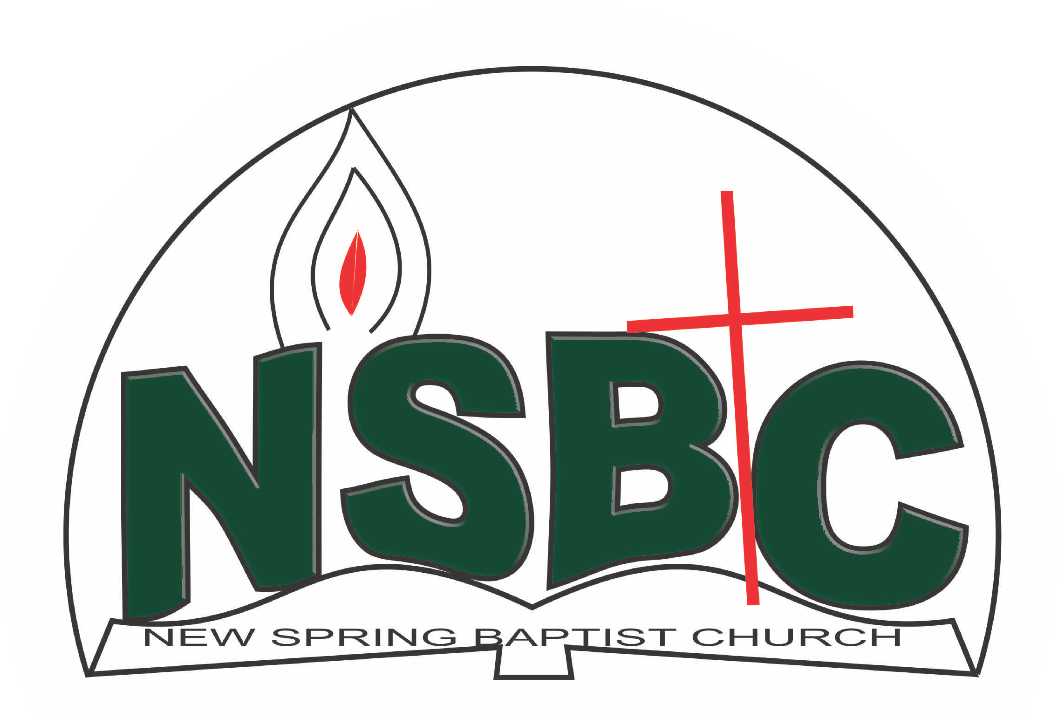

2 January 2022

Dear Mrs. Deborah Oyelami,

Nomination to Serve as a Worker in the Church in 2021.

Greetings in the precious name of our Lord and Saviour Jesus Christ. It is our pleasure to inform you that at the Church-in-Conference held on December 20, 2020; the Church ratified your nomination to serve in the following areas between January 1 and December 31, 2021:

1. Member, Intercessors Committee under the chairmanship of Mrs. Funke Oyekunle
2. Member, Health Committee under the Chairmanship of Mrs. Nia Olupona
3. Member, Music Committee

Please refer to the table below for the key functions of each of these roles. Details can be found in the Church constitution. You are strongly encouraged to become familiar with the tasks as stated in the document. There will be an orientation of the Church workers on January 22, 2021 at 8:30 a.m. on the church premises. Please ensure you participate in this training.

“Now it is required that those who have been given a trust must prove faithful. I Corinthians 4:2”. May God find you faithful in the task He has assigned to you.

| Domain | Key function of Office, Department or Committee |
| --- | --- |
| Member, Health Committee | Support the Church Pastor in providing professional guidance to the Church in health related matters of the Church members |
| Intercessors Committee | The committee is responsible for standing in the gap on behalf of the Church and her members |
| Music Ministry | Responsible for the music component of the Church’s worship and other programmes. |

Thank you for accepting to serve in this Church.

Yours in His service

Olusayo Okediji Blessed Agboola

Church Secretary Chairman, Nominating Committee